Kaleido
  - Presenter’s companion

The 12-slide AI-native executive overview
Make the step concept tangible. Show why AI can use the same model. Keep the business in charge.
Suggested pace: about 15-18 minutes, plus questions. Rehearse with the Say sections; present from the quick cues. Stage directions and presenter reminders are not meant to be read aloud.
YOUR ONE-PAGE CUE SHEET
# | SLIDE FOCUS | REMEMBER | PAGE
01 | The positioning | One business model, usable by people, applications, and AI. | 2
02 | Why I started | I built Kaleido to make the step concept tangible, not just explain it again. | 3
03 | Make steps click | The action stays the same even when the screen, conversation, or channel changes. | 4
04 | Why AI raises the stakes | Give AI the same business contract, not a second definition of the business. | 5
05 | The three building blocks | Information: what we know. Actions: what we do. Catalog: how to find them. | 6
06 | Where the pieces sit | Different interfaces lead to the same capability contracts and business implementations. | 7
07 | What AI can use | The agent reads explicit tools and process guidance instead of making up the workflow. | 8
08 | The spoken example | The person supplies facts and choices; the agent navigates; the service validates. | 9
09 | Continuity | Reload the process state, not just the previous chat history. | 10
10 | Adoption without replacement | Keep orchestration, channels, and external standards at their boundaries. | 11
11 | Authority and readiness | AI helps with interaction; permission, business meaning, and release guarantees stay explicit. | 12
12 | The close | Make the idea visible. Make AI a first-class user. Keep the business in charge. | 13
Likely questions and suggested answers: pages 14-15
BASIS AND SCOPE
Aligned to Kaleido_Executive_Overview_v3_AI_Native.pptx, all 12 slides and their original notes. The origin story follows your account. The dialogue is illustrative, and the preview qualifications are retained. This guide adds wording, not new implementation or release claims.

SLIDE 01 / 60-75 SECONDS

Business capabilities. Built for people and AI.
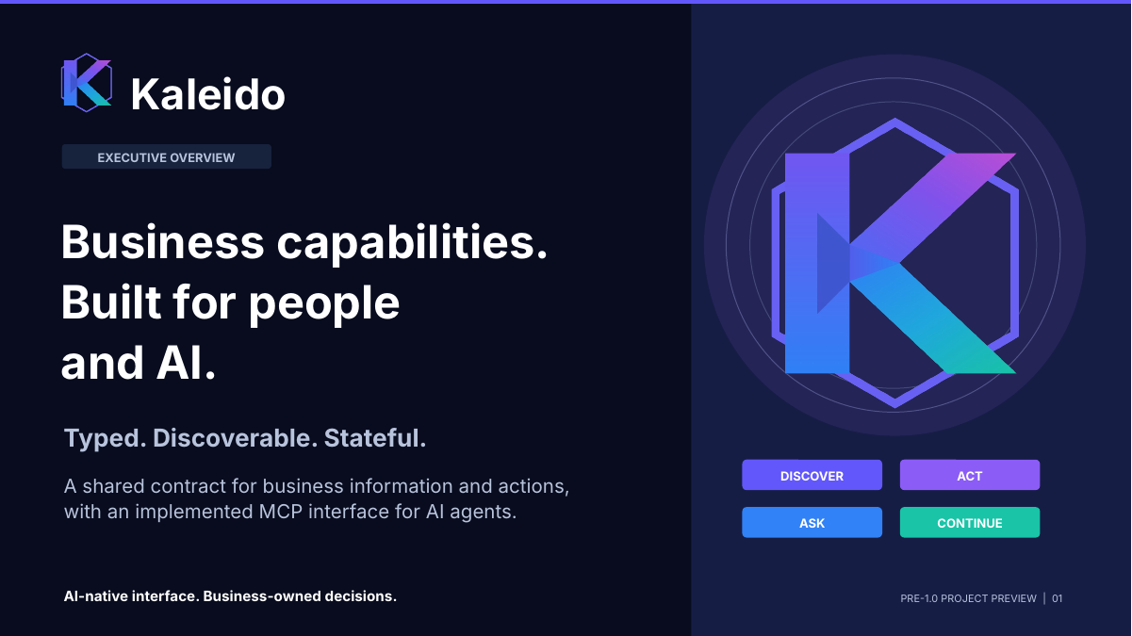 | REMEMBER  One business model, usable by people, applications, and AI.  On screen: Open on the headline. Use the four verbs on the right as a preview, not a technical checklist.
SAY
The simplest way to think about Kaleido is that it makes business information and business actions explicit enough for different consumers to use consistently. That consumer might be a web application, a person working through a contact center, or an AI assistant.
When I say a business capability, I mean something concrete: finding a member, selecting a provider, or submitting a request. The contract describes what that capability needs, what it returns, and, for a process, how the work can continue.
AI is now a first-class interface to that model through MCP, the Model Context Protocol. We are not moving the business into a chatbot. We are giving an AI assistant a structured way to interact with business capabilities that also serve other channels.
This is a pre-1.0 project preview. I want to walk through the idea, make the step concept tangible, and show why it matters more now that AI can use it.
TRANSITION TO THE NEXT SLIDE
Before I get into the architecture, I want to explain why I started building it.
Presenter reminder (not spoken): AI-native describes the implemented MCP interface, not a built-in language model or a production-readiness certification.
Basis: v3 deck, slide 01, including its original presenter notes and source qualifications.

SLIDE 02 / 60-90 SECONDS

The idea needed a working example.
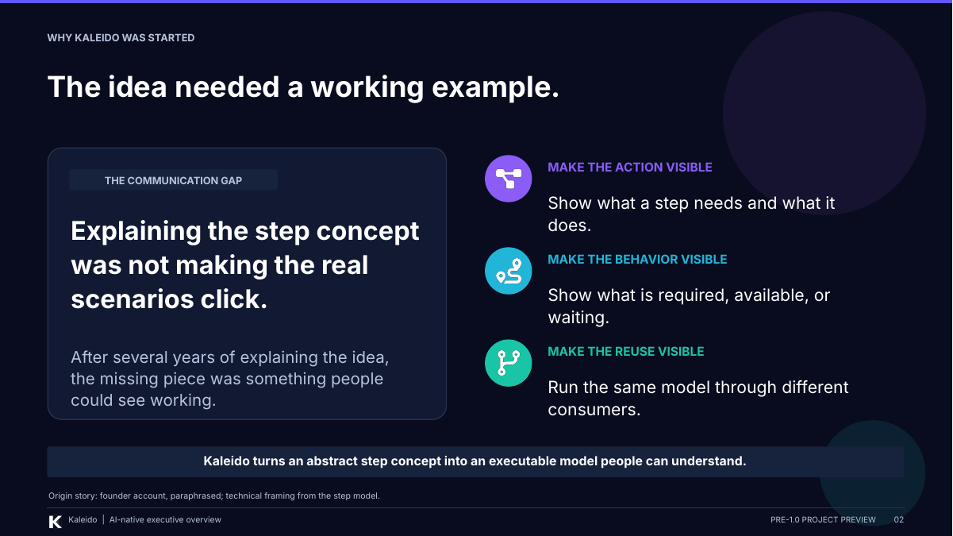 | REMEMBER  I built Kaleido to make the step concept tangible, not just explain it again.  On screen: Speak personally. Pause after the communication gap, then move through action, behavior, and reuse.
SAY
For the past few years, I have been trying to explain this idea of steps. I could describe the concept, but when we got into specific scenarios, I was not making it clear how the pieces would actually work together.
What I wanted people to be able to see was the behavior: what an action needs, what happens when it runs, what becomes available afterward, and what happens when the process needs more information.
That is the main reason I started Kaleido. Instead of asking people to imagine the model from another explanation, I wanted an executable example we could run, inspect, and discuss. The point was to make the idea concrete.
The AI importance has grown from that foundation. Once the actions, inputs, and ways to continue are explicit, an AI assistant has something structured to work with too. AI was not the original reason for the project, but it is now an important way to use the model.
TRANSITION TO THE NEXT SLIDE
The easiest way to make that click is to be very clear about what I mean by a step.
Presenter reminder (not spoken): This is a suggested first-person paraphrase of your account, not a quotation recovered from the repository.
Basis: v3 deck, slide 02, including its original presenter notes and source qualifications.

SLIDE 03 / 90-120 SECONDS

A step is a business action—not a screen.
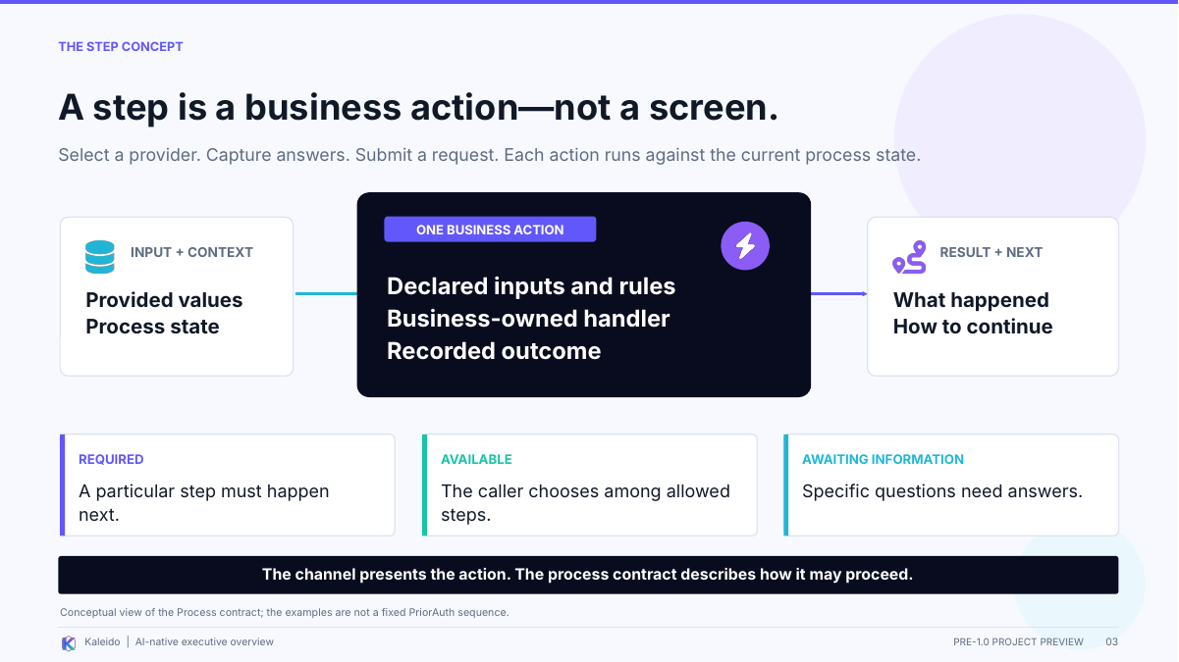 | REMEMBER  The action stays the same even when the screen, conversation, or channel changes.  On screen: Pause on "not a screen." Trace input to action to result, then point to the three continuation cards.
SAY
This is the distinction I most want people to leave with: a step is a business action, not a screen and not a chat message.
Take selecting a provider. A website might present a list. A contact-center employee might make the selection while talking to someone. An AI assistant might help the user find and choose the right record. Those are different interactions around the same business action.
The step receives its inputs and the current process context. Kaleido checks the declared input and process rules, invokes the business-owned handler, and records the outcome. The handler owns what the action means in the business.
The result is more useful than just success or failure. It also describes how to continue. A particular step might be required next. Several steps might be available for the caller to choose from. Or the process may be waiting for answers to specific questions.
So this is not simply page one, page two, page three. The channel presents the interaction; the process contract describes the permitted work. The consumer reads that guidance rather than inventing the next part of the journey.
TRANSITION TO THE NEXT SLIDE
Once we separate the action from the interface, we can see why rebuilding that logic for every new consumer is a problem.
Presenter reminder (not spoken): The three cards explain common continuation situations; they are not every possible process state or a fixed PriorAuth sequence.
Basis: v3 deck, slide 03, including its original presenter notes and source qualifications.

SLIDE 04 / 60-75 SECONDS

Do not create another integration path for AI.
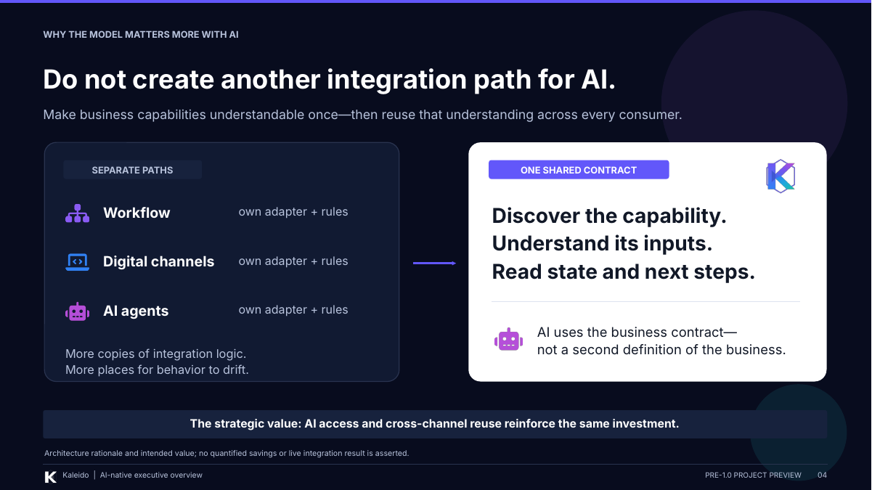 | REMEMBER  Give AI the same business contract, not a second definition of the business.  On screen: Contrast the separate paths on the left with the shared contract on the right.
SAY
The problem on the left is that each new consumer can become another place where we rebuild the same understanding of the business. The workflow integration has its assumptions. The digital channel has another set. Then we add an AI assistant and build yet another path.
Now the inputs, validation, error handling, and understanding of what happens next can start to drift. A change to the business can turn into changes in several integrations.
The goal on the right is to publish that capability contract once. Each consumer can discover the capability, understand its inputs, and read the process state and next steps.
This does not eliminate all integration work. The interfaces and boundary mappings still matter. What it aims to reduce is the repeated definition of the business underneath them. The same investment that supports cross-channel reuse also makes the business more usable by AI.
TRANSITION TO THE NEXT SLIDE
There are three building blocks underneath that shared contract.
Presenter reminder (not spoken): Describe reduced duplication as the intended value. The deck does not establish measured savings or zero-effort integration.
Basis: v3 deck, slide 04, including its original presenter notes and source qualifications.

SLIDE 05 / 60-90 SECONDS

Three building blocks. One AI-native interface.
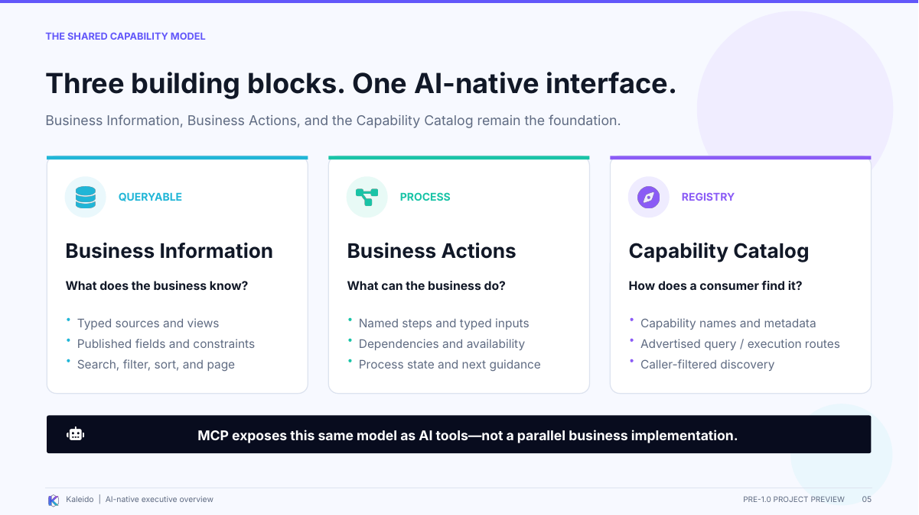 | REMEMBER  Information: what we know. Actions: what we do. Catalog: how to find them.  On screen: Walk left to right across Queryable, Process, and Registry. End on the MCP strip at the bottom.
SAY
I use three plain-language questions to explain the model.
First, what does the business know? That is Business Information, which Kaleido calls Queryable. It exposes typed sources and views, their fields and constraints, and the ways consumers can search, filter, sort, and page through information.
Second, what can the business do? That is Business Actions, which Kaleido calls Process. These are the named steps we just discussed, with their inputs, dependencies, availability, and process state.
Third, how does a consumer find those things? That is the Capability Catalog, or Registry. It publishes names, descriptions, metadata, and the routes for querying or executing capabilities, with discovery filtered for the caller.
MCP exposes that same model to an AI assistant as tools. It is not a fourth business runtime, and it is not a second implementation of the business rules. Information, actions, and discovery remain the foundation.
TRANSITION TO THE NEXT SLIDE
This next picture shows how those building blocks fit underneath both AI and the channels we already have.
Presenter reminder (not spoken): Caller-filtered discovery is an implemented mechanism; production authorization and downstream credential configuration still need validation.
Basis: v3 deck, slide 05, including its original presenter notes and source qualifications.

SLIDE 06 / 60-90 SECONDS

One model for human and AI consumers.
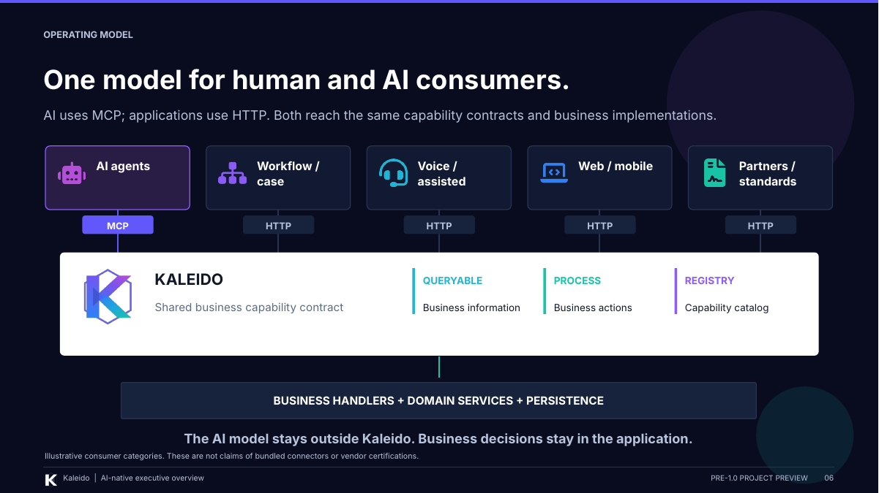 | REMEMBER  Different interfaces lead to the same capability contracts and business implementations.  On screen: Start with the AI lane at the top left. Move down to Kaleido, then down again to the business implementations.
SAY
Read this picture from top to bottom. The AI assistant comes through MCP. Workflow tools, assisted channels, web applications, and partner integrations can come through HTTP. The access path is different, but they reach the same information and action contracts.
The middle layer is Kaleido: the common description of what the business can provide and do, together with the process mechanisms for carrying out that work.
At the bottom are the business handlers, domain services, and persistence. That is where the application implements the business meaning. The language model stays outside Kaleido.
That separation matters. An AI assistant can help someone interact with the process without becoming the place where the business rules live. Likewise, an existing workflow or channel platform does not have to be replaced to participate.
These are integration categories, not a claim that every connector in this picture ships with the project.
TRANSITION TO THE NEXT SLIDE
With that architecture in mind, here is what the implemented AI-facing interface actually provides.
Presenter reminder (not spoken): Keep the distinction between an architectural integration path and a delivered vendor connector. The diagram omits detailed host authentication.
Basis: v3 deck, slide 06, including its original presenter notes and source qualifications.

SLIDE 07 / 90-120 SECONDS

AI can discover, act, ask, and continue.
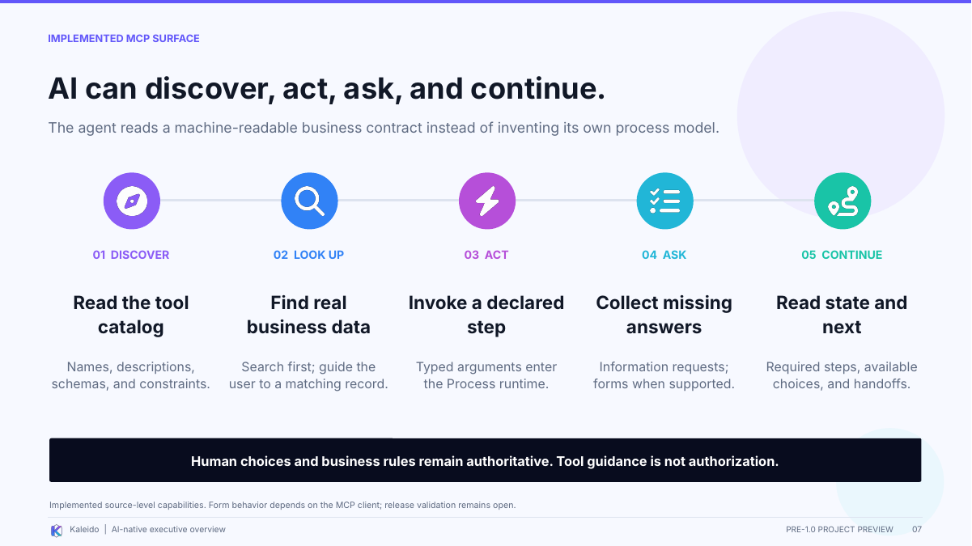 | REMEMBER  The agent reads explicit tools and process guidance instead of making up the workflow.  On screen: Move through the five stages in order. Slow down at "Ask" and "Continue"; these connect AI back to the step model.
SAY
Here is the AI story in practical terms. First, the agent can discover tools generated from the caller-visible catalog. Those tools describe the capabilities, their inputs, and their constraints.
Second, lookup metadata connects an action to the information needed to fill it. Rather than asking someone to know an internal identifier, the interaction can search for matching records and let the user choose the intended one.
Third, the agent can invoke a declared step with structured arguments. That call enters the Process runtime and the business handler; it is not free-form text replacing the action.
Fourth, the process can ask for missing information. The service supplies the questions, and the interface can present forms where the MCP client supports them. The agent is guided to obtain the user's answers, not invent them.
Finally, the consumer reads the returned state and next-step guidance. There may be a required step, available choices to offer the user, or a handoff. That is what makes this more than a list of callable functions: it also explains how the work can continue.
TRANSITION TO THE NEXT SLIDE
Let me make that concrete with a short PriorAuth example.
Presenter reminder (not spoken): Instructions, forms, and tool annotations guide interaction. They do not independently prove consent, authorization, or correct model behavior.
Basis: v3 deck, slide 07, including its original presenter notes and source qualifications.

SLIDE 08 / 90-120 SECONDS

From a conversation to a real business action.
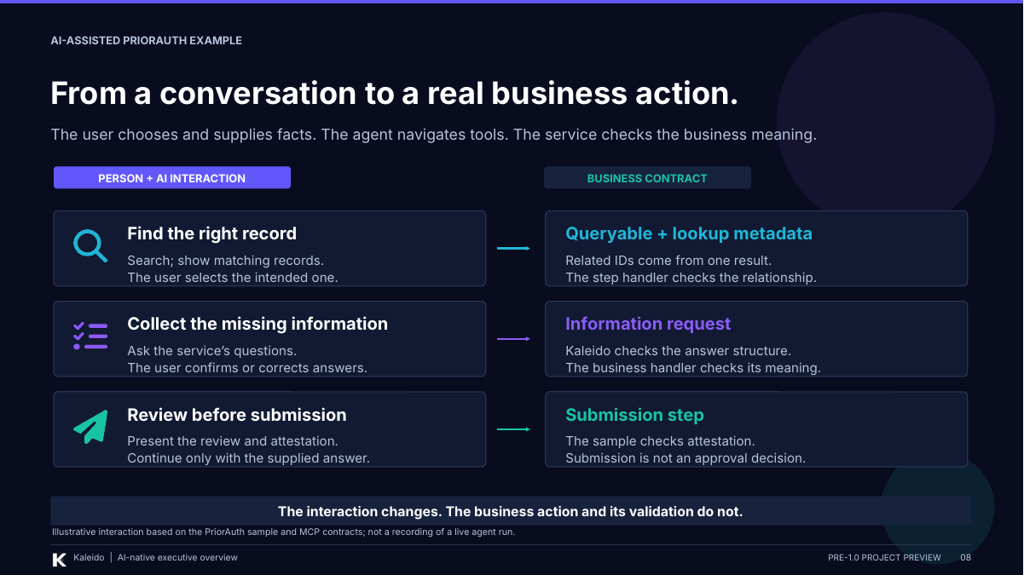 | REMEMBER  The person supplies facts and choices; the agent navigates; the service validates.  On screen: Use the left column for the conversation and the right column for what the business contract is doing.
SAY
Here is an illustrative conversation, not a recording of a live run. Imagine someone starting a prior-authorization request with an AI assistant.
Person: 'I need to start a request.'
AI assistant: 'Let's find the right member record first.'
The query returns matching records. The person selects the intended one, and the related identifiers come from that result. The business handler still checks that those identifiers belong together.
AI assistant: 'The service needs some more information. Here are its questions.'
The actual questions come from the service, not from an improvised clinical interview. The person provides, confirms, or corrects the answers. Kaleido checks the answer structure; the business handler checks what those answers mean.
AI assistant: 'Here is the request for review, along with the required attestation.'
The user supplies the attestation answer. In the sample, the submission handler checks that answer before recording submission. Submission is not an approval decision.
The important point is that the conversation is the interface. Underneath it are explicit queries, information requests, and actions. A web interface could present those interactions differently without redefining the business action.
TRANSITION TO THE NEXT SLIDE
And because the action belongs to a process rather than a chat, that work does not have to end when the conversation does.
Presenter reminder (not spoken): The dialogue is invented for explanation. Use the actual service-owned questions and attestation unchanged in a real demonstration. This is not the full workflow or proof of human consent.
Basis: v3 deck, slide 08, including its original presenter notes and source qualifications.

SLIDE 09 / 60-90 SECONDS

The process should outlive the conversation.
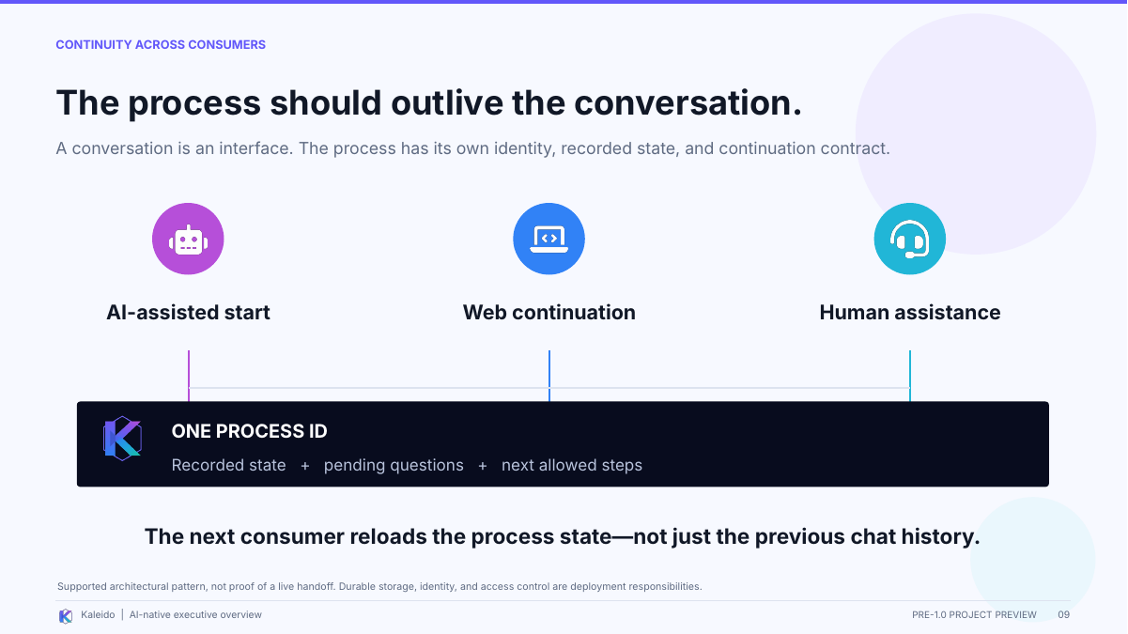 | REMEMBER  Reload the process state, not just the previous chat history.  On screen: Point across the three consumer icons, then to the single process-ID bar underneath.
SAY
A conversation is one way to interact with the business. It should not be the only place where the business knows what has happened.
In this model, the process has its own identity and recorded state: what has happened, what information is pending, and which steps are allowed next. A subsequent authorized consumer reads that state before continuing.
The scenario pictured here is an AI-assisted start, a continuation on the web, and then human assistance. The important idea is not those particular channels. It is that changing the interface should not require reconstructing the business process from the chat transcript.
This is an architectural pattern, not a claim that every live handoff has already been proven. It depends on the deployment's durable storage and access controls. A process ID identifies the work; it does not, by itself, establish that a person is authorized to access that case.
TRANSITION TO THE NEXT SLIDE
That continuity is also why this can strengthen the platforms we already use, rather than replace them.
Presenter reminder (not spoken): Cross-channel continuation and cross-processor handoff are different. The source sample still records an open handoff validation issue.
Basis: v3 deck, slide 09, including its original presenter notes and source qualifications.

SLIDE 10 / 60-75 SECONDS

AI strengthens the platforms already in place.
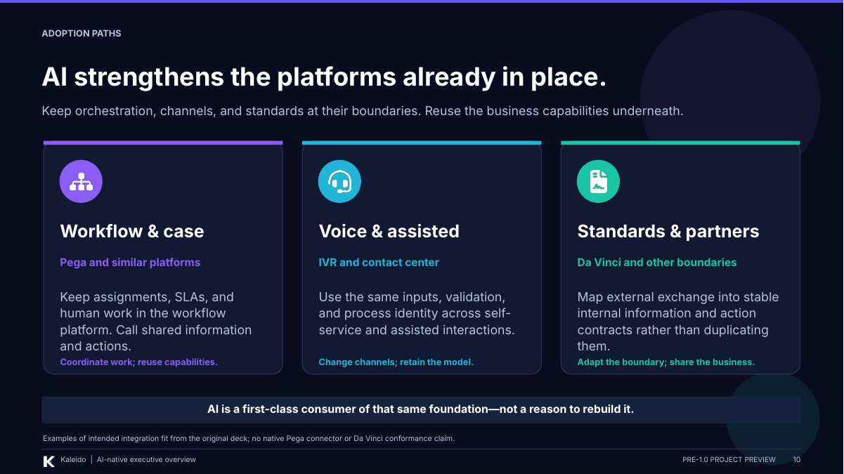 | REMEMBER  Keep orchestration, channels, and external standards at their boundaries.  On screen: Walk across the three platform groups. Emphasize what each platform keeps owning.
SAY
This is not a proposal to replace every platform with Kaleido. It is a way to make the business capabilities underneath those platforms more reusable.
Workflow and case-management platforms, such as the Pega example in the deck, keep their responsibilities for coordinating work, assignments, service-level commitments, and human tasks. They can call shared information and actions.
Voice and assisted channels keep their interaction model, while using the same inputs, validation, and process identity as digital experiences.
Standards and partner integrations keep the external exchange boundary. The integration maps that exchange into the internal business capabilities rather than introducing another definition of the business.
AI joins that same foundation through MCP. These examples show where the architecture is intended to fit; they are not claims of packaged connectors or standards certification.
TRANSITION TO THE NEXT SLIDE
The final boundary to make explicit is who has authority when an AI assistant participates.
Presenter reminder (not spoken): Do not imply that Pega, IVR, or Da Vinci integrations are delivered or certified by the project.
Basis: v3 deck, slide 10, including its original presenter notes and source qualifications.

SLIDE 11 / 90-120 SECONDS

AI-native does not mean unbounded.
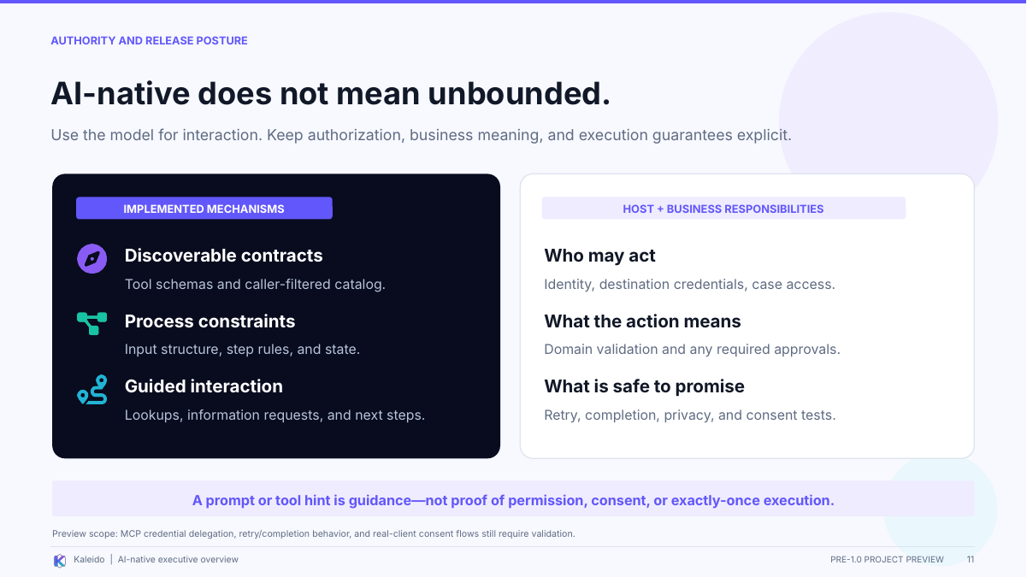 | REMEMBER  AI helps with interaction; permission, business meaning, and release guarantees stay explicit.  On screen: Separate the implemented mechanisms on the left from host and business responsibilities on the right.
SAY
This distinction is essential to the story. There are implemented mechanisms on the left: tool schemas, caller-filtered discovery, input structure, process rules, and guidance for lookups and continuation.
But those mechanisms do not transfer business authority to the model. The host and application must establish who may act, what records they may access, what an action means, and whether an approval is required.
A prompt that says 'ask for confirmation' is useful guidance. It is not the same as proving permission or consent. Similarly, describing an operation as retryable is not proof that its external effects will happen exactly once.
That is also why this deck says pre-1.0 preview. The reviews identify work still needing resolution and validation around MCP credential delegation, retries and completion, and real-client consent behavior. I am presenting an implemented interface and a clear architectural direction, not saying that every production guarantee has been established.
The principle is to make AI useful while keeping the business and its host responsible for authority.
TRANSITION TO THE NEXT SLIDE
That brings the project back to the original idea, with a much more important new way to use it.
Presenter reminder (not spoken): Review findings are not implemented fixes. Do not claim prompt-injection immunity, automatic approval, or arbitrary exactly-once external execution.
Basis: v3 deck, slide 11, including its original presenter notes and source qualifications.

SLIDE 12 / 45-60 SECONDS

Make the business understandable.
Make it usable by AI.
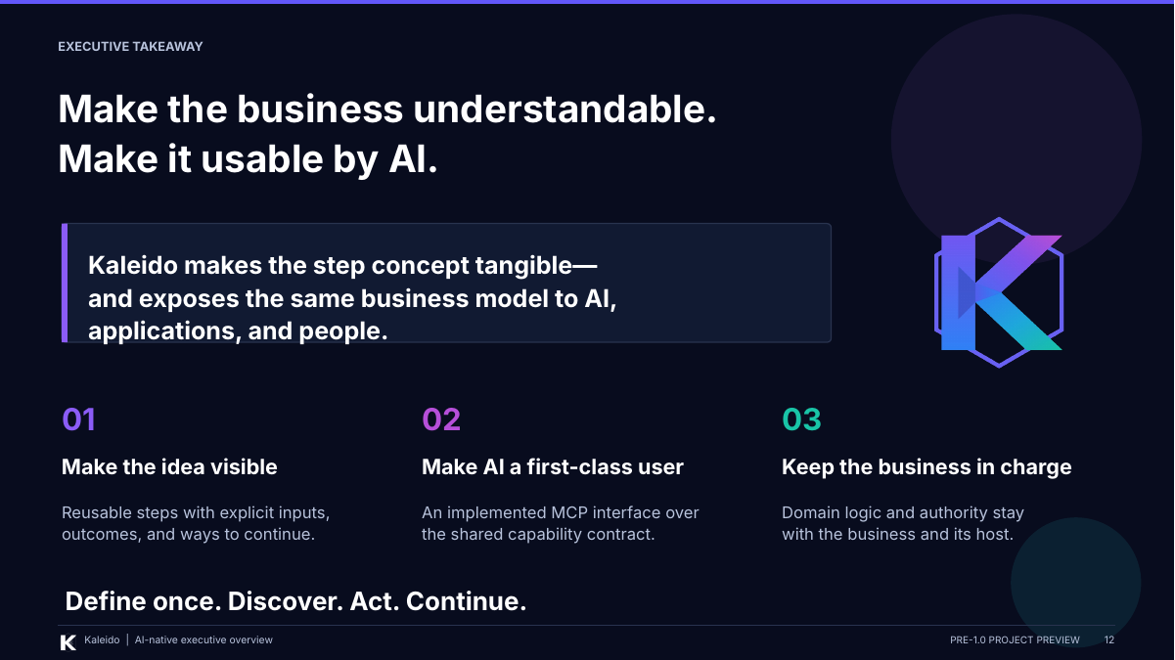 | REMEMBER  Make the idea visible. Make AI a first-class user. Keep the business in charge.  On screen: Connect the origin story to the three takeaways. Finish, pause, and invite questions.
SAY
The reason I started Kaleido was to make the step concept tangible. I wanted people to see what an action needs, what it does, and how the process can continue, instead of having to imagine all of that from a verbal explanation.
That same explicit model now gives us a practical AI interface. The assistant can discover capabilities, help gather the right information, and invoke business actions through MCP, while other applications use the same underlying contracts.
So there are three things I want to leave with you: make the idea visible, make AI a first-class consumer, and keep the business in charge.
The original challenge was making steps understandable. The new opportunity is making those same steps usable by AI, without redefining the business for every new consumer.
FINISH
Pause. Let the final line land, then invite questions.
Presenter reminder (not spoken): Keep the preview status visible. End on the shared model and business-owned authority, not an unproven adoption or release claim.
Basis: v3 deck, slide 12, including its original presenter notes and source qualifications.

Q&A / SUGGESTED ANSWERS

Questions you are likely to get
  - The step model and the AI interface
Use these when the discussion moves beyond the slide. They retain the same scope and qualifications as the deck.
Is a step just an API endpoint or a screen?
No. A screen is an interaction, and an endpoint is a way to call something. A step is a named business action with inputs, process relationships, a business handler, and an outcome. Kaleido also returns state and guidance about what may happen next. The same action can sit behind more than one interface.
Deck v3, slides 03, 05, and 06.
Do the steps have to run in a fixed order?
Not necessarily. Dependencies and availability rules constrain the choices. Sometimes a specific step is required; sometimes several steps are available for the caller to choose from; sometimes the process is waiting for information. Flexible does not mean arbitrary: the consumer follows the returned process guidance, and the runtime checks the declared rules.
Deck v3, slides 03 and 07.
What makes it AI-native if Kaleido does not contain a model?
AI-native here describes the interface. The implemented MCP adapter turns the shared capability catalog into tools with names, descriptions, schemas, and constraints, and supports lookups, information requests, and state-driven continuation. The AI model remains outside Kaleido. This is not a claim that Kaleido provides inference, retrieval, or an autonomous planner.
Deck v3, slides 01, 05, 06, and 07.
Does the AI choose the next action or approve a request?
The process exposes what is required or available, and the agent is guided to present available choices to the user. Business handlers own the domain decisions. In the PriorAuth example, submission is not approval. Agent guidance is not proof that every model or client will behave correctly; validation and authority must stay outside that guidance.
Deck v3, slides 03, 07, 08, and 11.
Is asking for confirmation enough to make an action safe?
No. A tool hint or prompt can guide the interaction, but it does not prove that a person consented. The application must implement whatever authorization and approval requirements the business needs. Even the sample attestation checks a submitted answer; it does not independently establish how an arbitrary client obtained that answer.
Deck v3, slides 08 and 11, including their qualifications.

Q&A / SUGGESTED ANSWERS

Questions you are likely to get
  - Integration, continuity, and release readiness
Is this replacing our workflow or case-management platform?
No. Kaleido includes a process runtime for business actions, but the deck does not position it as a replacement for the enterprise workflow or case platform. That platform retains work coordination, assignments, service-level management, and human tasks. Kaleido provides the reusable information and action contracts it can call.
Deck v3, slides 06 and 10.
What happens when the chat ends or someone changes channels?
The intended pattern is that the next authorized consumer uses the process ID to reload recorded state, pending information, and next steps. It does not rely only on the previous conversation. That depends on durable storage and the deployment's access controls. The diagram is not proof that every cross-channel or cross-processor path is already validated.
Deck v3, slide 09 and its qualifications.
Does Kaleido already include Pega, IVR, or Da Vinci connectors?
The deck uses those as examples of integration fit. It does not establish that packaged connectors or certified standards implementations are included. The MCP adapter is implemented in the reviewed source; the other examples describe where applications or boundary adapters can reuse the shared capability model.
Deck v3, slides 06, 07, and 10.
Is it production-ready or ready for 1.0?
This is a pre-1.0 preview, not a release approval. The reviewed material describes implemented runtime and MCP capabilities, but it also identifies unresolved credential-delegation, retry/completion, and client-consent concerns. Those need closure and validation against the release candidate, alongside the broader release checks. This presentation is not evidence that those checks have passed.
Deck v3, slide 11; cleanup-chatgpt.md, sections 5 and 15; cleanup-devin.md, KAL-REL-001.
What business value has been proven?
The proposition is to reduce duplicated integration logic and keep behavior more consistent as consumers change. The deck does not provide measured cost savings, delivery-time improvements, or adoption results. I would distinguish the implemented capability model from the value we still need to demonstrate in a concrete integration.
Deck v3, slide 04 and its presenter notes.
A useful line to return to: "The business action is stable; the interface can change."

